Setting Up Your Dependents on ReserveCalifornia.com

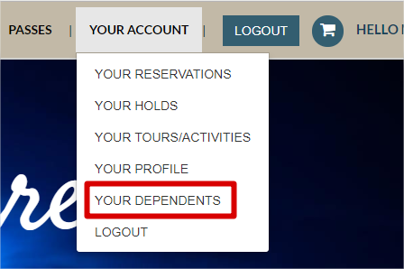
Step 1: Login or create your account on https://reservecalifornia.com/ by selecting the “LOGIN” button on the top menu.
Step 2: Once you are logged in, navigate to “YOUR ACCOUNT” on the top menu. A drop down will display. Select “YOUR DEPENDENTS” as shown below.
Step 3: A page titled “Persons” should appear. There will be a button that says “Add Person”. Click on this button to launch the “Add New Person” page.
Step 4: On the “Add New Person” page. Populate the following fields with information about the dependent you are setting up:
- First Name
- Last Name
- Birthdate This is necessary for ReserveCalifornia.com to validate that your dependent meets the age requirements for enrollment
- Relationship- Use drop down to select “Child”

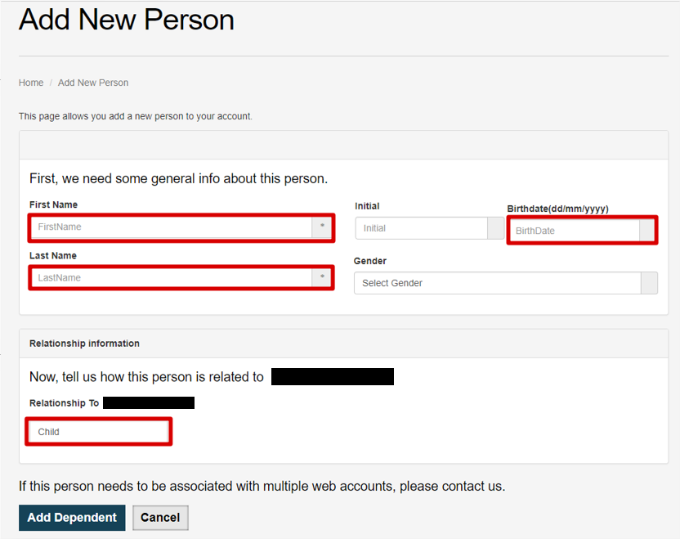
Step 5: Once you are done entering the above information, select “Add Dependent” and you will then be brought to the previous page and your new dependent should be listed. You can continue to add dependents to your account or proceed to enrolling in your dependent(s) in a Junior Lifeguard program.

